Irkutsk National Research Technical University Baikal school of BRICS

Course: Data analysis

Data Analysis Final Project.
Name : Liu Yiran
For a data set from the course:
1. Exploratory data analysis. Identify the underlying structure, patterns, anomalies, and relationships within the data. Formulate initial hypotheses about suitable modeling approaches and select relevant variables for further analysis.
2. Correlation: Select an appropriate dataset for correlation analysis using: Pearson correlation (for linear relationships between continuous, normally distributed variables) Spearman correlation (for monotonic relationships, ordinal/non-normal data) Biserial correlation (for one continuous and one dichotomous variable)
3.Regression:
1.) Univariate binary logistic regression. Calculating OR 95% CI and significance level. Visualization.
2.) Univariate logistic regression. Adjust the models by factors. Interpretation of the adjusted model.
3.) Multivariate binary logistic regression. Stepwise selection methods: backward, forward, mixed selection. Comparison of the results.
4.) Multivariate binary logistic regression. Adjust the model by factors. Interpretation of the adjusted model.
4.Cluster analysis (k-means).
5.Principal component analysis. Interpretation of principal components. Visualization.
Method: Correlation analysis
Code:
# Final Project - Complete Data Analysis in Base R
# Files used:
# 1) distribution*.csv
# 2) factor_data*.csv
# 3) imputed_data*.csv
# The script uses only packages included with a standard R installation.
# It creates tables and PNG figures in: analysis_results/
options(stringsAsFactors = FALSE, scipen = 999)
set.seed(20260620)
# 0. Utility functions
get_script_dir <- function() {
args <- commandArgs(trailingOnly = FALSE)
file_arg <- grep("^--file=", args, value = TRUE)
if (length(file_arg) > 0L) {
return(dirname(normalizePath(sub("^--file=", "", file_arg[1L]), mustWork = FALSE)))
}
getwd()
}
script_dir <- get_script_dir()
search_dirs <- unique(c(getwd(), script_dir))
locate_input_file <- function(pattern, label) {
candidates <- character(0)
for (d in search_dirs) {
if (dir.exists(d)) {
candidates <- c(
candidates,
list.files(d, pattern = "\\.csv$", full.names = TRUE, recursive = FALSE, ignore.case = TRUE)
)
}
}
candidates <- unique(candidates)
matched <- candidates[grepl(pattern, basename(candidates), ignore.case = TRUE)]
if (length(matched) >= 1L) {
matched <- matched[order(nchar(basename(matched)), basename(matched))]
message("Using ", label, ": ", normalizePath(matched[1L], mustWork = FALSE))
return(matched[1L])
}
if (interactive()) {
message("Could not automatically find ", label, ". Please select it in the file dialog.")
return(file.choose())
}
stop(
"Could not find ", label,
". Put the three CSV files in the working directory or run this script interactively in RStudio."
)
}
clean_names <- function(x) {
x <- sub("^\\ufeff", "", x)
y <- tryCatch(
suppressWarnings(iconv(x, from = "", to = "ASCII//TRANSLIT")),
error = function(e) rep(NA_character_, length(x))
)
y[is.na(y)] <- x[is.na(y)]
y <- tolower(y)
y <- gsub("[^a-z0-9]+", "_", y)
y <- gsub("^_+|_+$", "", y)
make.unique(y, sep = "_")
}
as_numeric_safe <- function(x) {
if (is.numeric(x)) return(as.numeric(x))
x <- trimws(as.character(x))
x[x %in% c("", "NA", "NaN", "NULL", ".")] <- NA_character_
x <- gsub(",", ".", x, fixed = TRUE)
suppressWarnings(as.numeric(x))
}
skewness_base <- function(x) {
x <- x[is.finite(x)]
if (length(x) < 3L) return(NA_real_)
s <- stats::sd(x)
if (!is.finite(s) || s == 0) return(0)
mean(((x - mean(x)) / s)^3)
}
safe_exp <- function(x) {
out <- exp(pmax(pmin(x, 700), -700))
out[!is.finite(out)] <- NA_real_
out
}
safe_cor_test <- function(x, y, method = "pearson") {
ok <- is.finite(x) & is.finite(y)
if (sum(ok) < 4L || stats::sd(x[ok]) == 0 || stats::sd(y[ok]) == 0) {
return(c(estimate = NA_real_, p_value = NA_real_))
}
z <- tryCatch(
suppressWarnings(stats::cor.test(x[ok], y[ok], method = method, exact = FALSE)),
error = function(e) NULL
)
if (is.null(z)) return(c(estimate = NA_real_, p_value = NA_real_))
c(estimate = unname(z$estimate), p_value = z$p.value)
}
roc_auc <- function(y, probability) {
ok <- is.finite(y) & is.finite(probability)
y <- as.integer(y[ok])
probability <- probability[ok]
n1 <- sum(y == 1L)
n0 <- sum(y == 0L)
if (n1 == 0L || n0 == 0L) return(NA_real_)
ranks <- rank(probability, ties.method = "average")
(sum(ranks[y == 1L]) - n1 * (n1 + 1) / 2) / (n1 * n0)
}
roc_points <- function(y, probability) {
ok <- is.finite(y) & is.finite(probability)
y <- as.integer(y[ok])
probability <- probability[ok]
n1 <- sum(y == 1L)
n0 <- sum(y == 0L)
if (n1 == 0L || n0 == 0L) {
return(data.frame(fpr = c(0, 1), tpr = c(0, 1)))
}
ord <- order(probability, decreasing = TRUE)
y <- y[ord]
data.frame(
fpr = c(0, cumsum(y == 0L) / n0),
tpr = c(0, cumsum(y == 1L) / n1)
)
}
safe_predict_probability <- function(model, newdata) {
tryCatch(
as.numeric(stats::predict(model, newdata = newdata, type = "response")),
error = function(e) rep(NA_real_, nrow(newdata))
)
}
save_png <- function(filename, code, width = 2400, height = 1600, res = 180) {
grDevices::png(filename = filename, width = width, height = height, res = res)
on.exit(grDevices::dev.off(), add = TRUE)
force(code)
invisible(filename)
}
make_formula <- function(response, terms) {
terms <- unique(terms[nzchar(terms)])
if (length(terms) == 0L) {
stats::as.formula(paste(response, "~ 1"))
} else {
stats::reformulate(terms, response = response)
}
}
fit_glm_safe <- function(formula, data) {
tryCatch(
suppressWarnings(stats::glm(formula, data = data, family = stats::binomial())),
error = function(e) NULL
)
}
step_safe <- function(start_model, lower_formula, upper_formula, direction) {
if (is.null(start_model)) return(NULL)
tryCatch(
suppressWarnings(
stats::step(
start_model,
scope = list(lower = lower_formula, upper = upper_formula),
direction = direction,
trace = 0
)
),
error = function(e) start_model
)
}
forest_plot <- function(results, title, output_file, max_terms = 15L) {
needed <- c("term", "OR", "lower95", "upper95", "p_value")
if (!all(needed %in% names(results))) return(invisible(FALSE))
d <- results[
is.finite(results$OR) & is.finite(results$lower95) & is.finite(results$upper95) &
results$OR > 0 & results$lower95 > 0 & results$upper95 > 0,
, drop = FALSE
]
if (nrow(d) == 0L) return(invisible(FALSE))
d <- d[order(d$p_value, na.last = TRUE), , drop = FALSE]
d <- head(d, max_terms)
d <- d[nrow(d):1L, , drop = FALSE]
log_lower <- log(d$lower95)
log_upper <- log(d$upper95)
log_or <- log(d$OR)
finite_range <- range(c(log_lower, log_upper), finite = TRUE)
if (!all(is.finite(finite_range)) || diff(finite_range) == 0) finite_range <- c(-1, 1)
display_cap <- log(20)
xlim <- c(max(finite_range[1], -display_cap), min(finite_range[2], display_cap))
xlim <- range(c(xlim, 0))
if (diff(xlim) == 0) xlim <- c(-1, 1)
pad <- 0.08 * diff(xlim)
xlim <- xlim + c(-pad, pad)
save_png(output_file, {
old_par <- graphics::par(mar = c(5, 12, 4, 2) + 0.1)
on.exit(graphics::par(old_par), add = TRUE)
y <- seq_len(nrow(d))
graphics::plot(
log_or, y,
xlim = xlim, ylim = c(0.5, nrow(d) + 0.5),
pch = 19, yaxt = "n", xaxt = "n",
xlab = "Odds ratio (log scale)", ylab = "", main = title
)
shown_lower <- pmax(log_lower, xlim[1])
shown_upper <- pmin(log_upper, xlim[2])
shown_or <- pmax(pmin(log_or, xlim[2]), xlim[1])
graphics::segments(shown_lower, y, shown_upper, y, lwd = 2)
graphics::points(shown_or, y, pch = 19)
if (any(log_lower < xlim[1])) graphics::points(rep(xlim[1], sum(log_lower < xlim[1])), y[log_lower < xlim[1]], pch = 4)
if (any(log_upper > xlim[2])) graphics::points(rep(xlim[2], sum(log_upper > xlim[2])), y[log_upper > xlim[2]], pch = 4)
graphics::abline(v = 0, lty = 2)
graphics::axis(2, at = y, labels = d$term, las = 2, cex.axis = 0.75)
tick_log <- pretty(xlim, n = 7)
graphics::axis(1, at = tick_log, labels = format(round(exp(tick_log), 3), trim = TRUE))
graphics::box()
}, width = 2600, height = 1800, res = 180)
invisible(TRUE)
}
# 1. Locate and read data
distribution_file <- locate_input_file("distribution", "distribution data")
factor_file <- locate_input_file("factor[_ ]?data|factor", "factor data")
imputed_file <- locate_input_file("imputed[_ ]?data|imputed", "imputed continuous data")
output_dir <- file.path(script_dir, "analysis_results")
plot_dir <- file.path(output_dir, "figures")
table_dir <- file.path(output_dir, "tables")
dir.create(plot_dir, recursive = TRUE, showWarnings = FALSE)
dir.create(table_dir, recursive = TRUE, showWarnings = FALSE)
distribution_data <- utils::read.csv(
distribution_file,
sep = ";", header = TRUE, stringsAsFactors = FALSE,
check.names = FALSE, na.strings = c("", "NA", "NaN")
)
factor_data <- utils::read.csv(
factor_file,
header = TRUE, stringsAsFactors = FALSE,
check.names = FALSE, na.strings = c("", "NA", "NaN")
)
imputed_data <- utils::read.csv(
imputed_file,
header = TRUE, stringsAsFactors = FALSE,
check.names = FALSE, na.strings = c("", "NA", "NaN")
)
names(distribution_data) <- clean_names(names(distribution_data))
names(factor_data) <- clean_names(names(factor_data))
names(imputed_data) <- clean_names(names(imputed_data))
# Normalize the visually similar Cyrillic/Latin first letter in carb_metabolism.
carb_index <- grep("arb_metabolism", names(imputed_data), fixed = TRUE)
if (length(carb_index) >= 1L) names(imputed_data)[carb_index[1L]] <- "carb_metabolism"
required_distribution <- c("distribution", "value")
required_factor <- c("record_id", "outcome")
if (!all(required_distribution %in% names(distribution_data))) {
stop("The distribution CSV must contain columns named distribution and value.")
}
if (!all(required_factor %in% names(factor_data))) {
stop("The factor CSV must contain record_id and outcome.")
}
if (!"record_id" %in% names(imputed_data)) {
stop("The imputed CSV must contain record_id.")
}
distribution_data$value <- as_numeric_safe(distribution_data$value)
distribution_data$distribution <- as.factor(trimws(as.character(distribution_data$distribution)))
distribution_data <- distribution_data[
!is.na(distribution_data$distribution) & is.finite(distribution_data$value),
, drop = FALSE
]
factor_numeric_columns <- intersect(
c("record_id", "outcome", "factor_eth", "factor_h", "factor_pcos", "factor_prl"),
names(factor_data)
)
for (v in factor_numeric_columns) factor_data[[v]] <- as_numeric_safe(factor_data[[v]])
imputed_data$record_id <- as_numeric_safe(imputed_data$record_id)
for (v in setdiff(names(imputed_data), "record_id")) {
imputed_data[[v]] <- as_numeric_safe(imputed_data[[v]])
}
merged_raw <- merge(factor_data, imputed_data, by = "record_id", all = FALSE, sort = FALSE)
merged_raw <- merged_raw[!is.na(merged_raw$outcome), , drop = FALSE]
merged_raw$outcome <- as.integer(merged_raw$outcome)
outcome_values <- sort(unique(merged_raw$outcome))
if (!identical(outcome_values, c(0L, 1L))) {
stop("Outcome must be binary and coded as 0 and 1.")
}
# Preserve the original missingness pattern before categorical-value handling.
missing_snapshot <- merged_raw
factor_vars <- intersect(c("factor_eth", "factor_h", "factor_pcos", "factor_prl"), names(merged_raw))
factor_missing_handling <- data.frame(
variable = factor_vars,
missing_n = integer(length(factor_vars)),
missing_percent = numeric(length(factor_vars)),
method = character(length(factor_vars)),
replacement = character(length(factor_vars)),
stringsAsFactors = FALSE
)
for (i in seq_along(factor_vars)) {
v <- factor_vars[i]
z <- trimws(as.character(merged_raw[[v]]))
missing <- is.na(z) | z == ""
missing_fraction <- mean(missing)
factor_missing_handling$missing_n[i] <- sum(missing)
factor_missing_handling$missing_percent[i] <- 100 * missing_fraction
if (any(missing) && missing_fraction <= 0.05) {
observed <- z[!missing]
replacement <- names(sort(table(observed), decreasing = TRUE))[1L]
z[missing] <- replacement
factor_missing_handling$method[i] <- "mode imputation"
factor_missing_handling$replacement[i] <- replacement
} else if (any(missing)) {
z[missing] <- "Missing"
factor_missing_handling$method[i] <- "explicit Missing category"
factor_missing_handling$replacement[i] <- "Missing"
} else {
factor_missing_handling$method[i] <- "no missing values"
factor_missing_handling$replacement[i] <- "none"
}
merged_raw[[v]] <- factor(z)
}
continuous_vars <- setdiff(names(imputed_data), "record_id")
continuous_vars <- continuous_vars[continuous_vars %in% names(merged_raw)]
for (v in continuous_vars) {
merged_raw[[v]][!is.finite(merged_raw[[v]])] <- NA_real_
}
if (length(continuous_vars) < 2L) stop("At least two continuous variables are required.")
# 2. Data preparation and documentation
missing_summary <- data.frame(
variable = names(missing_snapshot),
missing_n = vapply(missing_snapshot, function(x) sum(is.na(x)), integer(1)),
missing_percent = vapply(missing_snapshot, function(x) mean(is.na(x)) * 100, numeric(1)),
stringsAsFactors = FALSE
)
missing_summary <- missing_summary[order(missing_summary$missing_percent, decreasing = TRUE), ]
utils::write.csv(missing_summary, file.path(table_dir, "01_missing_summary.csv"), row.names = FALSE)
utils::write.csv(
factor_missing_handling,
file.path(table_dir, "01b_factor_missing_handling.csv"),
row.names = FALSE
)
outlier_summary <- do.call(rbind, lapply(continuous_vars, function(v) {
x <- merged_raw[[v]]
q <- stats::quantile(x, probs = c(0.25, 0.75), na.rm = TRUE, names = FALSE)
iqr <- q[2L] - q[1L]
lower <- q[1L] - 1.5 * iqr
upper <- q[2L] + 1.5 * iqr
data.frame(
variable = v,
lower_iqr_fence = lower,
upper_iqr_fence = upper,
outlier_n = sum(x < lower | x > upper, na.rm = TRUE),
outlier_percent = mean(x < lower | x > upper, na.rm = TRUE) * 100,
stringsAsFactors = FALSE
)
}))
utils::write.csv(outlier_summary, file.path(table_dir, "02_iqr_outlier_summary.csv"), row.names = FALSE)
# Median imputation for the remaining missing continuous values.
analysis_data <- merged_raw
imputation_summary <- data.frame(
variable = continuous_vars,
median_used = NA_real_,
imputed_n = NA_integer_,
stringsAsFactors = FALSE
)
all_missing_vars <- character(0)
for (i in seq_along(continuous_vars)) {
v <- continuous_vars[i]
x <- analysis_data[[v]]
n_missing <- sum(is.na(x))
med <- suppressWarnings(stats::median(x, na.rm = TRUE))
if (!is.finite(med)) {
all_missing_vars <- c(all_missing_vars, v)
next
}
x[is.na(x)] <- med
analysis_data[[v]] <- x
imputation_summary$median_used[i] <- med
imputation_summary$imputed_n[i] <- n_missing
}
if (length(all_missing_vars) > 0L) {
continuous_vars <- setdiff(continuous_vars, all_missing_vars)
imputation_summary <- imputation_summary[!imputation_summary$variable %in% all_missing_vars, ]
}
utils::write.csv(imputation_summary, file.path(table_dir, "03_median_imputation.csv"), row.names = FALSE)
# Remove zero-variance variables, then log1p-transform strongly right-skewed nonnegative variables.
variable_preparation <- data.frame(
variable = continuous_vars,
skewness_before = NA_real_,
transformation = "none",
mean_after = NA_real_,
sd_after = NA_real_,
stringsAsFactors = FALSE
)
transformed_matrix <- analysis_data[, continuous_vars, drop = FALSE]
for (i in seq_along(continuous_vars)) {
v <- continuous_vars[i]
x <- transformed_matrix[[v]]
sk <- skewness_base(x)
variable_preparation$skewness_before[i] <- sk
if (is.finite(sk) && abs(sk) > 1 && min(x, na.rm = TRUE) >= 0) {
transformed_matrix[[v]] <- log1p(x)
variable_preparation$transformation[i] <- "log1p"
}
variable_preparation$mean_after[i] <- mean(transformed_matrix[[v]])
variable_preparation$sd_after[i] <- stats::sd(transformed_matrix[[v]])
}
nonzero_variance <- vapply(transformed_matrix, function(x) {
s <- stats::sd(x)
is.finite(s) && s > 0
}, logical(1))
transformed_matrix <- transformed_matrix[, nonzero_variance, drop = FALSE]
continuous_vars <- names(transformed_matrix)
variable_preparation <- variable_preparation[variable_preparation$variable %in% continuous_vars, ]
utils::write.csv(variable_preparation, file.path(table_dir, "04_variable_transformations.csv"), row.names = FALSE)
scaled_matrix <- scale(as.matrix(transformed_matrix))
scaled_matrix[!is.finite(scaled_matrix)] <- 0
model_data <- data.frame(
outcome = analysis_data$outcome,
as.data.frame(scaled_matrix, check.names = FALSE),
analysis_data[, factor_vars, drop = FALSE],
check.names = FALSE
)
# Descriptive statistics for continuous variables.
descriptive_statistics <- do.call(rbind, lapply(continuous_vars, function(v) {
x <- analysis_data[[v]]
data.frame(
variable = v,
n = sum(is.finite(x)),
mean = mean(x, na.rm = TRUE),
sd = stats::sd(x, na.rm = TRUE),
median = stats::median(x, na.rm = TRUE),
q1 = stats::quantile(x, 0.25, na.rm = TRUE, names = FALSE),
q3 = stats::quantile(x, 0.75, na.rm = TRUE, names = FALSE),
min = min(x, na.rm = TRUE),
max = max(x, na.rm = TRUE),
skewness = skewness_base(x),
stringsAsFactors = FALSE
)
}))
utils::write.csv(descriptive_statistics, file.path(table_dir, "05_descriptive_statistics.csv"), row.names = FALSE)
# 3. Exploratory data analysis figures
distribution_levels <- levels(droplevels(distribution_data$distribution))
save_png(file.path(plot_dir, "01_distribution_histograms_and_qqplots.png"), {
old_par <- graphics::par(
mfrow = c(length(distribution_levels), 2L),
mar = c(4, 4, 3, 1) + 0.1
)
on.exit(graphics::par(old_par), add = TRUE)
for (g in distribution_levels) {
x <- distribution_data$value[distribution_data$distribution == g]
graphics::hist(
x, probability = TRUE, breaks = "FD",
main = paste("Histogram:", g), xlab = "Value", border = "white"
)
if (length(unique(x)) > 1L) {
den <- stats::density(x)
graphics::lines(den, lwd = 2)
}
stats::qqnorm(x, main = paste("Normal Q-Q:", g), pch = 19, cex = 0.65)
stats::qqline(x, lwd = 2)
}
}, width = 2400, height = max(1800, 650 * length(distribution_levels)), res = 180)
save_png(file.path(plot_dir, "02_distribution_boxplot.png"), {
old_par <- graphics::par(mar = c(5, 5, 4, 2) + 0.1)
on.exit(graphics::par(old_par), add = TRUE)
graphics::boxplot(
value ~ distribution, data = distribution_data,
xlab = "Distribution", ylab = "Value",
main = "Comparison of the Four Generated Distributions"
)
}, width = 2200, height = 1500, res = 180)
normality_results <- do.call(rbind, lapply(distribution_levels, function(g) {
x <- distribution_data$value[distribution_data$distribution == g]
shapiro <- if (length(x) >= 3L && length(x) <= 5000L && length(unique(x)) >= 3L) {
tryCatch(stats::shapiro.test(x), error = function(e) NULL)
} else NULL
data.frame(
distribution = g,
n = length(x),
mean = mean(x),
sd = stats::sd(x),
median = stats::median(x),
skewness = skewness_base(x),
shapiro_W = if (is.null(shapiro)) NA_real_ else unname(shapiro$statistic),
shapiro_p = if (is.null(shapiro)) NA_real_ else shapiro$p.value,
stringsAsFactors = FALSE
)
}))
normality_results$shapiro_p_fdr <- stats::p.adjust(normality_results$shapiro_p, method = "BH")
utils::write.csv(normality_results, file.path(table_dir, "06_distribution_normality_tests.csv"), row.names = FALSE)
plot_missing <- missing_summary[missing_summary$missing_n > 0L, , drop = FALSE]
if (nrow(plot_missing) > 0L) {
save_png(file.path(plot_dir, "03_missing_data_percent.png"), {
old_par <- graphics::par(mar = c(5, 12, 4, 2) + 0.1)
on.exit(graphics::par(old_par), add = TRUE)
d <- plot_missing[nrow(plot_missing):1L, ]
graphics::barplot(
d$missing_percent,
names.arg = d$variable,
horiz = TRUE, las = 1,
xlab = "Missing values (%)",
main = "Missing Data in the Merged Dataset Before Handling"
)
}, width = 2400, height = 1600, res = 180)
}
hist_cols <- ceiling(sqrt(length(continuous_vars)))
hist_rows <- ceiling(length(continuous_vars) / hist_cols)
save_png(file.path(plot_dir, "04_continuous_variable_histograms.png"), {
old_par <- graphics::par(mfrow = c(hist_rows, hist_cols), mar = c(3, 3, 2.5, 0.5) + 0.1)
on.exit(graphics::par(old_par), add = TRUE)
for (v in continuous_vars) {
graphics::hist(
analysis_data[[v]], breaks = "FD",
main = v, xlab = "", ylab = "Frequency",
border = "white"
)
}
}, width = 3200, height = max(2600, hist_rows * 520), res = 180)
if (length(factor_vars) > 0L) {
fac_cols <- ceiling(sqrt(length(factor_vars)))
fac_rows <- ceiling(length(factor_vars) / fac_cols)
save_png(file.path(plot_dir, "05_outcome_rate_by_factors.png"), {
old_par <- graphics::par(mfrow = c(fac_rows, fac_cols), mar = c(5, 4, 3, 1) + 0.1)
on.exit(graphics::par(old_par), add = TRUE)
for (v in factor_vars) {
tab <- table(analysis_data[[v]], analysis_data$outcome)
rates <- if ("1" %in% colnames(tab)) tab[, "1"] / rowSums(tab) else rep(0, nrow(tab))
graphics::barplot(
rates,
names.arg = rownames(tab),
ylim = c(0, max(0.25, rates, na.rm = TRUE) * 1.15),
ylab = "Outcome = 1 proportion", xlab = v,
main = paste("Outcome rate by", v)
)
}
}, width = 2600, height = 1900, res = 180)
}
# 4. Correlation analysis
pearson_matrix <- stats::cor(
analysis_data[, continuous_vars, drop = FALSE],
use = "pairwise.complete.obs", method = "pearson"
)
spearman_matrix <- stats::cor(
analysis_data[, continuous_vars, drop = FALSE],
use = "pairwise.complete.obs", method = "spearman"
)
utils::write.csv(pearson_matrix, file.path(table_dir, "07_pearson_correlation_matrix.csv"), row.names = TRUE)
utils::write.csv(spearman_matrix, file.path(table_dir, "08_spearman_correlation_matrix.csv"), row.names = TRUE)
save_png(file.path(plot_dir, "06_pearson_correlation_heatmap.png"), {
p <- ncol(pearson_matrix)
palette_fun <- grDevices::colorRampPalette(c("navy", "white", "firebrick3"))
old_par <- graphics::par(mar = c(11, 11, 4, 2) + 0.1)
on.exit(graphics::par(old_par), add = TRUE)
graphics::image(
x = seq_len(p), y = seq_len(p),
z = t(pearson_matrix[p:1L, , drop = FALSE]),
axes = FALSE, xlab = "", ylab = "",
col = palette_fun(101), zlim = c(-1, 1),
main = "Pearson Correlation Heatmap"
)
graphics::axis(1, at = seq_len(p), labels = colnames(pearson_matrix), las = 2, cex.axis = 0.65)
graphics::axis(2, at = seq_len(p), labels = rev(rownames(pearson_matrix)), las = 2, cex.axis = 0.65)
graphics::box()
}, width = 3000, height = 2800, res = 180)
outcome_correlations <- do.call(rbind, lapply(continuous_vars, function(v) {
pearson <- safe_cor_test(analysis_data[[v]], analysis_data$outcome, method = "pearson")
spearman <- safe_cor_test(analysis_data[[v]], analysis_data$outcome, method = "spearman")
data.frame(
variable = v,
point_biserial_r = pearson["estimate"],
point_biserial_p = pearson["p_value"],
spearman_rho = spearman["estimate"],
spearman_p = spearman["p_value"],
stringsAsFactors = FALSE,
row.names = NULL
)
}))
outcome_correlations$point_biserial_p_fdr <- stats::p.adjust(outcome_correlations$point_biserial_p, method = "BH")
outcome_correlations$point_biserial_p_bonferroni <- stats::p.adjust(
outcome_correlations$point_biserial_p, method = "bonferroni"
)
outcome_correlations <- outcome_correlations[
order(abs(outcome_correlations$point_biserial_r), decreasing = TRUE),
]
utils::write.csv(outcome_correlations, file.path(table_dir, "09_correlations_with_binary_outcome.csv"), row.names = FALSE)
top_correlations <- head(outcome_correlations, min(15L, nrow(outcome_correlations)))
save_png(file.path(plot_dir, "07_point_biserial_correlations.png"), {
d <- top_correlations[nrow(top_correlations):1L, ]
old_par <- graphics::par(mar = c(5, 12, 4, 2) + 0.1)
on.exit(graphics::par(old_par), add = TRUE)
graphics::barplot(
d$point_biserial_r,
names.arg = d$variable,
horiz = TRUE, las = 1,
xlab = "Point-biserial correlation with outcome",
main = "Strongest Continuous-Variable Associations with Outcome"
)
graphics::abline(v = 0, lty = 2)
}, width = 2500, height = 1800, res = 180)
boxplot_vars <- head(outcome_correlations$variable, min(8L, nrow(outcome_correlations)))
box_cols <- 2L
box_rows <- ceiling(length(boxplot_vars) / box_cols)
save_png(file.path(plot_dir, "08_top_variables_by_outcome_boxplots.png"), {
old_par <- graphics::par(mfrow = c(box_rows, box_cols), mar = c(4, 4, 3, 1) + 0.1)
on.exit(graphics::par(old_par), add = TRUE)
for (v in boxplot_vars) {
graphics::boxplot(
analysis_data[[v]] ~ analysis_data$outcome,
xlab = "Outcome", ylab = v,
main = paste(v, "by outcome")
)
}
}, width = 2400, height = max(1800, box_rows * 650), res = 180)
# ---------------------------
# 5. Univariate and adjusted logistic regression
# ---------------------------
univariate_results <- do.call(rbind, lapply(continuous_vars, function(v) {
f <- make_formula("outcome", v)
fit <- fit_glm_safe(f, model_data)
if (is.null(fit)) return(NULL)
co <- summary(fit)$coefficients
if (!v %in% rownames(co)) return(NULL)
est <- co[v, "Estimate"]
se <- co[v, "Std. Error"]
data.frame(
term = v,
beta = est,
standard_error = se,
OR = safe_exp(est),
lower95 = safe_exp(est - 1.96 * se),
upper95 = safe_exp(est + 1.96 * se),
p_value = co[v, "Pr(>|z|)"],
stringsAsFactors = FALSE
)
}))
if (is.null(univariate_results) || nrow(univariate_results) == 0L) {
stop("No univariate logistic regression model could be fitted.")
}
univariate_results$p_fdr <- stats::p.adjust(univariate_results$p_value, method = "BH")
univariate_results$p_bonferroni <- stats::p.adjust(univariate_results$p_value, method = "bonferroni")
univariate_results <- univariate_results[order(univariate_results$p_value), ]
utils::write.csv(univariate_results, file.path(table_dir, "10_univariate_logistic_regression.csv"), row.names = FALSE)
forest_plot(
univariate_results,
"Univariate Binary Logistic Regression (OR per 1 SD)",
file.path(plot_dir, "09_univariate_logistic_forest_plot.png")
)
adjusted_univariate_results <- do.call(rbind, lapply(continuous_vars, function(v) {
f <- make_formula("outcome", c(v, factor_vars))
fit <- fit_glm_safe(f, model_data)
if (is.null(fit)) return(NULL)
co <- summary(fit)$coefficients
if (!v %in% rownames(co)) return(NULL)
est <- co[v, "Estimate"]
se <- co[v, "Std. Error"]
data.frame(
term = v,
beta = est,
standard_error = se,
OR = safe_exp(est),
lower95 = safe_exp(est - 1.96 * se),
upper95 = safe_exp(est + 1.96 * se),
p_value = co[v, "Pr(>|z|)"],
adjusted_for = if (length(factor_vars) == 0L) "none" else paste(factor_vars, collapse = ", "),
stringsAsFactors = FALSE
)
}))
if (!is.null(adjusted_univariate_results) && nrow(adjusted_univariate_results) > 0L) {
adjusted_univariate_results$p_fdr <- stats::p.adjust(adjusted_univariate_results$p_value, method = "BH")
adjusted_univariate_results$p_bonferroni <- stats::p.adjust(
adjusted_univariate_results$p_value, method = "bonferroni"
)
adjusted_univariate_results <- adjusted_univariate_results[
order(adjusted_univariate_results$p_value),
]
utils::write.csv(
adjusted_univariate_results,
file.path(table_dir, "11_factor_adjusted_univariate_logistic_regression.csv"),
row.names = FALSE
)
forest_plot(
adjusted_univariate_results,
"Factor-Adjusted Univariate Logistic Regression (OR per 1 SD)",
file.path(plot_dir, "10_adjusted_univariate_logistic_forest_plot.png")
)
}
# 6. Train-test split and multivariate stepwise models
make_stratified_split <- function(data, outcome_name, factor_names, train_fraction = 0.75) {
y <- data[[outcome_name]]
train_index <- integer(0)
for (class_value in sort(unique(y))) {
idx <- which(y == class_value)
n_train <- max(1L, floor(length(idx) * train_fraction))
train_index <- c(train_index, sample(idx, n_train))
}
train_index <- sort(unique(train_index))
# Ensure that every observed factor level is represented in training data.
for (v in factor_names) {
for (lev in levels(data[[v]])) {
level_rows <- which(data[[v]] == lev)
if (length(level_rows) > 0L && !any(level_rows %in% train_index)) {
train_index <- sort(unique(c(train_index, sample(level_rows, 1L))))
}
}
}
train_index
}
train_index <- make_stratified_split(model_data, "outcome", factor_vars, train_fraction = 0.75)
train_data <- model_data[train_index, , drop = FALSE]
test_data <- model_data[-train_index, , drop = FALSE]
# Candidate selection is performed using training data only.
training_univariate <- do.call(rbind, lapply(continuous_vars, function(v) {
fit <- fit_glm_safe(make_formula("outcome", v), train_data)
if (is.null(fit)) return(NULL)
co <- summary(fit)$coefficients
if (!v %in% rownames(co)) return(NULL)
data.frame(variable = v, p_value = co[v, "Pr(>|z|)"], stringsAsFactors = FALSE)
}))
training_univariate <- training_univariate[order(training_univariate$p_value), ]
candidate_count <- min(12L, nrow(training_univariate))
candidate_vars <- head(training_univariate$variable, candidate_count)
if (length(candidate_vars) < 2L) candidate_vars <- head(continuous_vars, min(5L, length(continuous_vars)))
utils::write.csv(
data.frame(candidate_variable = candidate_vars),
file.path(table_dir, "12_multivariate_candidate_variables.csv"),
row.names = FALSE
)
null_formula <- make_formula("outcome", character(0))
full_formula <- make_formula("outcome", candidate_vars)
adjusted_lower_formula <- make_formula("outcome", factor_vars)
adjusted_upper_formula <- make_formula("outcome", c(factor_vars, candidate_vars))
null_model <- fit_glm_safe(null_formula, train_data)
full_model <- fit_glm_safe(full_formula, train_data)
adjusted_lower_model <- fit_glm_safe(adjusted_lower_formula, train_data)
adjusted_full_model <- fit_glm_safe(adjusted_upper_formula, train_data)
models <- list(
backward = step_safe(full_model, null_formula, full_formula, "backward"),
forward = step_safe(null_model, null_formula, full_formula, "forward"),
mixed = step_safe(full_model, null_formula, full_formula, "both"),
adjusted_backward = step_safe(adjusted_full_model, adjusted_lower_formula, adjusted_upper_formula, "backward"),
adjusted_forward = step_safe(adjusted_lower_model, adjusted_lower_formula, adjusted_upper_formula, "forward"),
adjusted_mixed = step_safe(adjusted_full_model, adjusted_lower_formula, adjusted_upper_formula, "both")
)
models <- models[!vapply(models, is.null, logical(1))]
model_comparison <- do.call(rbind, lapply(names(models), function(model_name) {
model <- models[[model_name]]
p_train <- safe_predict_probability(model, train_data)
p_test <- safe_predict_probability(model, test_data)
term_labels <- attr(stats::terms(model), "term.labels")
data.frame(
model = model_name,
number_of_terms = length(term_labels),
selected_terms = if (length(term_labels) == 0L) "Intercept only" else paste(term_labels, collapse = "; "),
AIC = stats::AIC(model),
train_AUC = roc_auc(train_data$outcome, p_train),
test_AUC = roc_auc(test_data$outcome, p_test),
stringsAsFactors = FALSE
)
}))
model_comparison <- model_comparison[order(model_comparison$test_AUC, decreasing = TRUE, na.last = TRUE), ]
utils::write.csv(model_comparison, file.path(table_dir, "13_stepwise_model_comparison.csv"), row.names = FALSE)
# Final adjusted model: adjusted mixed model when available; otherwise best available model.
if ("adjusted_mixed" %in% names(models)) {
final_model_name <- "adjusted_mixed"
} else if (nrow(model_comparison) > 0L) {
final_model_name <- model_comparison$model[1L]
} else {
final_model_name <- names(models)[1L]
}
final_model <- models[[final_model_name]]
final_co <- summary(final_model)$coefficients
final_co <- final_co[rownames(final_co) != "(Intercept)", , drop = FALSE]
final_model_results <- if (nrow(final_co) > 0L) {
data.frame(
term = rownames(final_co),
beta = final_co[, "Estimate"],
standard_error = final_co[, "Std. Error"],
OR = safe_exp(final_co[, "Estimate"]),
lower95 = safe_exp(final_co[, "Estimate"] - 1.96 * final_co[, "Std. Error"]),
upper95 = safe_exp(final_co[, "Estimate"] + 1.96 * final_co[, "Std. Error"]),
p_value = final_co[, "Pr(>|z|)"],
stringsAsFactors = FALSE,
row.names = NULL
)
} else {
data.frame(
term = character(0), beta = numeric(0), standard_error = numeric(0),
OR = numeric(0), lower95 = numeric(0), upper95 = numeric(0), p_value = numeric(0)
)
}
if (nrow(final_model_results) > 0L) {
final_model_results$p_fdr <- stats::p.adjust(final_model_results$p_value, method = "BH")
final_model_results <- final_model_results[order(final_model_results$p_value), ]
}
utils::write.csv(final_model_results, file.path(table_dir, "14_final_multivariate_model_coefficients.csv"), row.names = FALSE)
if (nrow(final_model_results) > 0L) {
forest_plot(
final_model_results,
paste("Final Multivariate Logistic Model:", final_model_name),
file.path(plot_dir, "11_final_multivariate_logistic_forest_plot.png"),
max_terms = 25L
)
}
# ROC curves for all fitted stepwise models on the test set.
save_png(file.path(plot_dir, "12_test_set_roc_curves.png"), {
old_par <- graphics::par(mar = c(5, 5, 4, 2) + 0.1)
on.exit(graphics::par(old_par), add = TRUE)
graphics::plot(
c(0, 1), c(0, 1), type = "n",
xlab = "False positive rate", ylab = "True positive rate",
main = "Test-Set ROC Curves for Stepwise Logistic Models",
xlim = c(0, 1), ylim = c(0, 1)
)
graphics::abline(0, 1, lty = 2)
line_types <- seq_along(models)
line_colors <- seq_along(models)
legend_labels <- character(length(models))
for (i in seq_along(models)) {
model_name <- names(models)[i]
probability <- safe_predict_probability(models[[i]], test_data)
roc <- roc_points(test_data$outcome, probability)
auc <- roc_auc(test_data$outcome, probability)
graphics::lines(roc$fpr, roc$tpr, lwd = 2, lty = line_types[i], col = line_colors[i])
legend_labels[i] <- paste0(model_name, " (AUC=", format(round(auc, 3), nsmall = 3), ")")
}
graphics::legend(
"bottomright", legend = legend_labels,
lty = line_types, col = line_colors, lwd = 2, cex = 0.75, bty = "n"
)
}, width = 2200, height = 1700, res = 180)
# Final model threshold metrics on the independent test set.
final_test_probability <- safe_predict_probability(final_model, test_data)
final_test_prediction <- ifelse(final_test_probability >= 0.5, 1L, 0L)
tp <- sum(final_test_prediction == 1L & test_data$outcome == 1L, na.rm = TRUE)
tn <- sum(final_test_prediction == 0L & test_data$outcome == 0L, na.rm = TRUE)
fp <- sum(final_test_prediction == 1L & test_data$outcome == 0L, na.rm = TRUE)
fn <- sum(final_test_prediction == 0L & test_data$outcome == 1L, na.rm = TRUE)
validation_metrics <- data.frame(
final_model = final_model_name,
train_n = nrow(train_data),
test_n = nrow(test_data),
test_AUC = roc_auc(test_data$outcome, final_test_probability),
accuracy_at_0_5 = (tp + tn) / max(1, tp + tn + fp + fn),
sensitivity_at_0_5 = tp / max(1, tp + fn),
specificity_at_0_5 = tn / max(1, tn + fp),
positive_predictive_value_at_0_5 = tp / max(1, tp + fp),
negative_predictive_value_at_0_5 = tn / max(1, tn + fn),
stringsAsFactors = FALSE
)
utils::write.csv(validation_metrics, file.path(table_dir, "15_final_model_validation_metrics.csv"), row.names = FALSE)
# 7. Principal component analysis
pca <- stats::prcomp(scaled_matrix, center = FALSE, scale. = FALSE)
pca_variance <- (pca$sdev^2) / sum(pca$sdev^2)
pca_summary <- data.frame(
component = paste0("PC", seq_along(pca_variance)),
variance_explained = pca_variance,
cumulative_variance = cumsum(pca_variance),
stringsAsFactors = FALSE
)
utils::write.csv(pca_summary, file.path(table_dir, "16_pca_variance_explained.csv"), row.names = FALSE)
save_png(file.path(plot_dir, "13_pca_scree_plot.png"), {
old_par <- graphics::par(mar = c(5, 5, 4, 5) + 0.1)
on.exit(graphics::par(old_par), add = TRUE)
x <- seq_along(pca_variance)
bar_midpoints <- graphics::barplot(
pca_variance * 100,
names.arg = x,
xlab = "Principal component", ylab = "Variance explained (%)",
main = "PCA Scree Plot"
)
graphics::par(new = TRUE)
graphics::plot(
bar_midpoints, cumsum(pca_variance) * 100,
type = "b", pch = 19, axes = FALSE, xlab = "", ylab = "",
xlim = range(bar_midpoints) + c(-0.5, 0.5), ylim = c(0, 100)
)
graphics::axis(4)
graphics::mtext("Cumulative variance (%)", side = 4, line = 3)
graphics::abline(h = 80, lty = 2)
}, width = 2200, height = 1600, res = 180)
pca_scores <- pca$x[, 1:2, drop = FALSE]
pca_loadings <- pca$rotation[, 1:2, drop = FALSE]
loading_strength <- rowSums(pca_loadings^2)
top_loading_names <- names(sort(loading_strength, decreasing = TRUE))[seq_len(min(10L, length(loading_strength)))]
save_png(file.path(plot_dir, "14_pca_biplot_by_outcome.png"), {
old_par <- graphics::par(mar = c(5, 5, 4, 2) + 0.1)
on.exit(graphics::par(old_par), add = TRUE)
outcome_colors <- ifelse(analysis_data$outcome == 1L, "firebrick3", "steelblue4")
outcome_symbols <- ifelse(analysis_data$outcome == 1L, 17, 16)
graphics::plot(
pca_scores[, 1], pca_scores[, 2],
col = outcome_colors, pch = outcome_symbols, cex = 0.65,
xlab = paste0("PC1 (", round(100 * pca_variance[1], 1), "%)"),
ylab = paste0("PC2 (", round(100 * pca_variance[2], 1), "%)"),
main = "PCA Scores and Major Loadings by Outcome"
)
selected_loadings <- pca_loadings[top_loading_names, , drop = FALSE]
score_scale <- min(
diff(range(pca_scores[, 1])) / max(1e-9, diff(range(selected_loadings[, 1]))),
diff(range(pca_scores[, 2])) / max(1e-9, diff(range(selected_loadings[, 2])))
) * 0.25
graphics::arrows(
0, 0,
selected_loadings[, 1] * score_scale,
selected_loadings[, 2] * score_scale,
length = 0.08, lwd = 1.5
)
graphics::text(
selected_loadings[, 1] * score_scale,
selected_loadings[, 2] * score_scale,
labels = rownames(selected_loadings), pos = 3, cex = 0.7
)
graphics::legend(
"topright", legend = c("Outcome 0", "Outcome 1"),
col = c("steelblue4", "firebrick3"), pch = c(16, 17), bty = "n"
)
}, width = 2400, height = 1800, res = 180)
# 8. K-means clustering
pc_80 <- which(cumsum(pca_variance) >= 0.80)[1L]
if (!is.finite(pc_80)) pc_80 <- min(10L, ncol(pca$x))
cluster_pc_count <- max(2L, min(10L, pc_80, ncol(pca$x)))
cluster_input <- pca$x[, seq_len(cluster_pc_count), drop = FALSE]
k_values <- 2:6
k_values <- k_values[k_values < nrow(cluster_input)]
k_solutions <- lapply(k_values, function(k) {
stats::kmeans(cluster_input, centers = k, nstart = 50, iter.max = 100)
})
withinss <- vapply(k_solutions, function(x) x$tot.withinss, numeric(1))
ch_index <- vapply(seq_along(k_values), function(i) {
k <- k_values[i]
fit <- k_solutions[[i]]
between <- fit$betweenss
within <- fit$tot.withinss
if (within <= 0 || nrow(cluster_input) <= k) return(NA_real_)
(between / (k - 1)) / (within / (nrow(cluster_input) - k))
}, numeric(1))
ch_for_selection <- ch_index
ch_for_selection[!is.finite(ch_for_selection)] <- -Inf
best_index <- if (all(ch_for_selection == -Inf)) 1L else which.max(ch_for_selection)
best_k <- k_values[best_index]
best_kmeans <- k_solutions[[best_index]]
kmeans_selection <- data.frame(
k = k_values,
total_within_cluster_ss = withinss,
calinski_harabasz_index = ch_index,
stringsAsFactors = FALSE
)
utils::write.csv(kmeans_selection, file.path(table_dir, "17_kmeans_k_selection.csv"), row.names = FALSE)
save_png(file.path(plot_dir, "15_kmeans_elbow_and_ch_index.png"), {
old_par <- graphics::par(mfrow = c(1, 2), mar = c(5, 5, 4, 1) + 0.1)
on.exit(graphics::par(old_par), add = TRUE)
graphics::plot(
k_values, withinss, type = "b", pch = 19,
xlab = "Number of clusters (k)", ylab = "Total within-cluster sum of squares",
main = "K-means Elbow Plot"
)
graphics::plot(
k_values, ch_index, type = "b", pch = 19,
xlab = "Number of clusters (k)", ylab = "Calinski-Harabasz index",
main = paste("Cluster Selection; chosen k =", best_k)
)
graphics::abline(v = best_k, lty = 2)
}, width = 2500, height = 1500, res = 180)
save_png(file.path(plot_dir, "16_kmeans_clusters_in_pca_space.png"), {
old_par <- graphics::par(mar = c(5, 5, 4, 2) + 0.1)
on.exit(graphics::par(old_par), add = TRUE)
cluster_colors <- best_kmeans$cluster
graphics::plot(
pca_scores[, 1], pca_scores[, 2],
col = cluster_colors, pch = 19, cex = 0.65,
xlab = paste0("PC1 (", round(100 * pca_variance[1], 1), "%)"),
ylab = paste0("PC2 (", round(100 * pca_variance[2], 1), "%)"),
main = paste("K-means Clusters in PCA Space (k =", best_k, ")")
)
graphics::legend(
"topright", legend = paste("Cluster", seq_len(best_k)),
col = seq_len(best_k), pch = 19, bty = "n"
)
}, width = 2200, height = 1700, res = 180)
cluster_output <- data.frame(
record_id = analysis_data$record_id,
outcome = analysis_data$outcome,
cluster = best_kmeans$cluster,
PC1 = pca_scores[, 1],
PC2 = pca_scores[, 2]
)
utils::write.csv(cluster_output, file.path(table_dir, "18_cluster_assignments.csv"), row.names = FALSE)
cluster_outcome_table <- aggregate(
outcome ~ cluster,
data = cluster_output,
FUN = function(x) c(n = length(x), outcome_1_n = sum(x == 1L), outcome_1_rate = mean(x == 1L))
)
cluster_outcome_summary <- data.frame(
cluster = cluster_outcome_table$cluster,
n = cluster_outcome_table$outcome[, "n"],
outcome_1_n = cluster_outcome_table$outcome[, "outcome_1_n"],
outcome_1_rate = cluster_outcome_table$outcome[, "outcome_1_rate"]
)
utils::write.csv(cluster_outcome_summary, file.path(table_dir, "19_cluster_outcome_summary.csv"), row.names = FALSE)
save_png(file.path(plot_dir, "17_outcome_rate_by_cluster.png"), {
old_par <- graphics::par(mar = c(5, 5, 4, 2) + 0.1)
on.exit(graphics::par(old_par), add = TRUE)
graphics::barplot(
cluster_outcome_summary$outcome_1_rate,
names.arg = paste("Cluster", cluster_outcome_summary$cluster),
ylim = c(0, max(0.25, cluster_outcome_summary$outcome_1_rate) * 1.15),
xlab = "K-means cluster", ylab = "Outcome = 1 proportion",
main = "Outcome Rate Across K-means Clusters"
)
}, width = 2100, height = 1500, res = 180)
Result:
Fifures 1: distribution histograms and qqplots
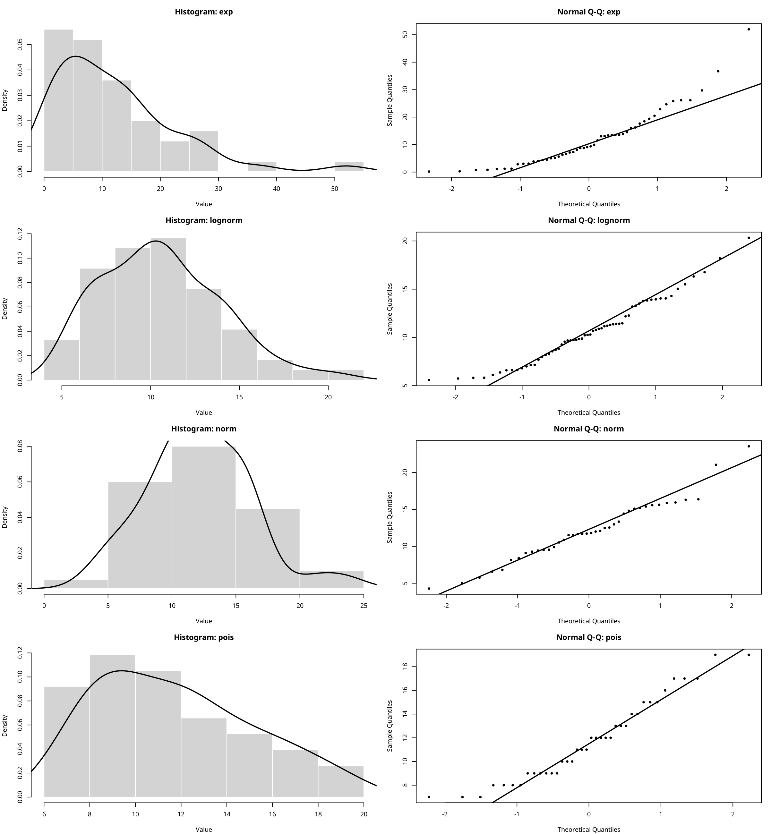
Fifures 2: pearson correlation heatmap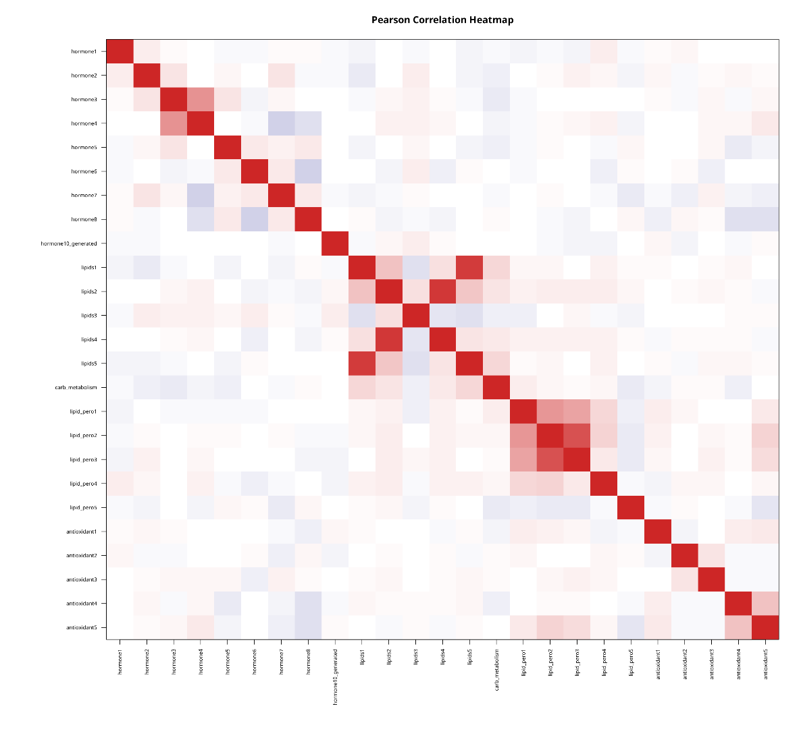
Fifures 3 : top variables by outcome boxplots
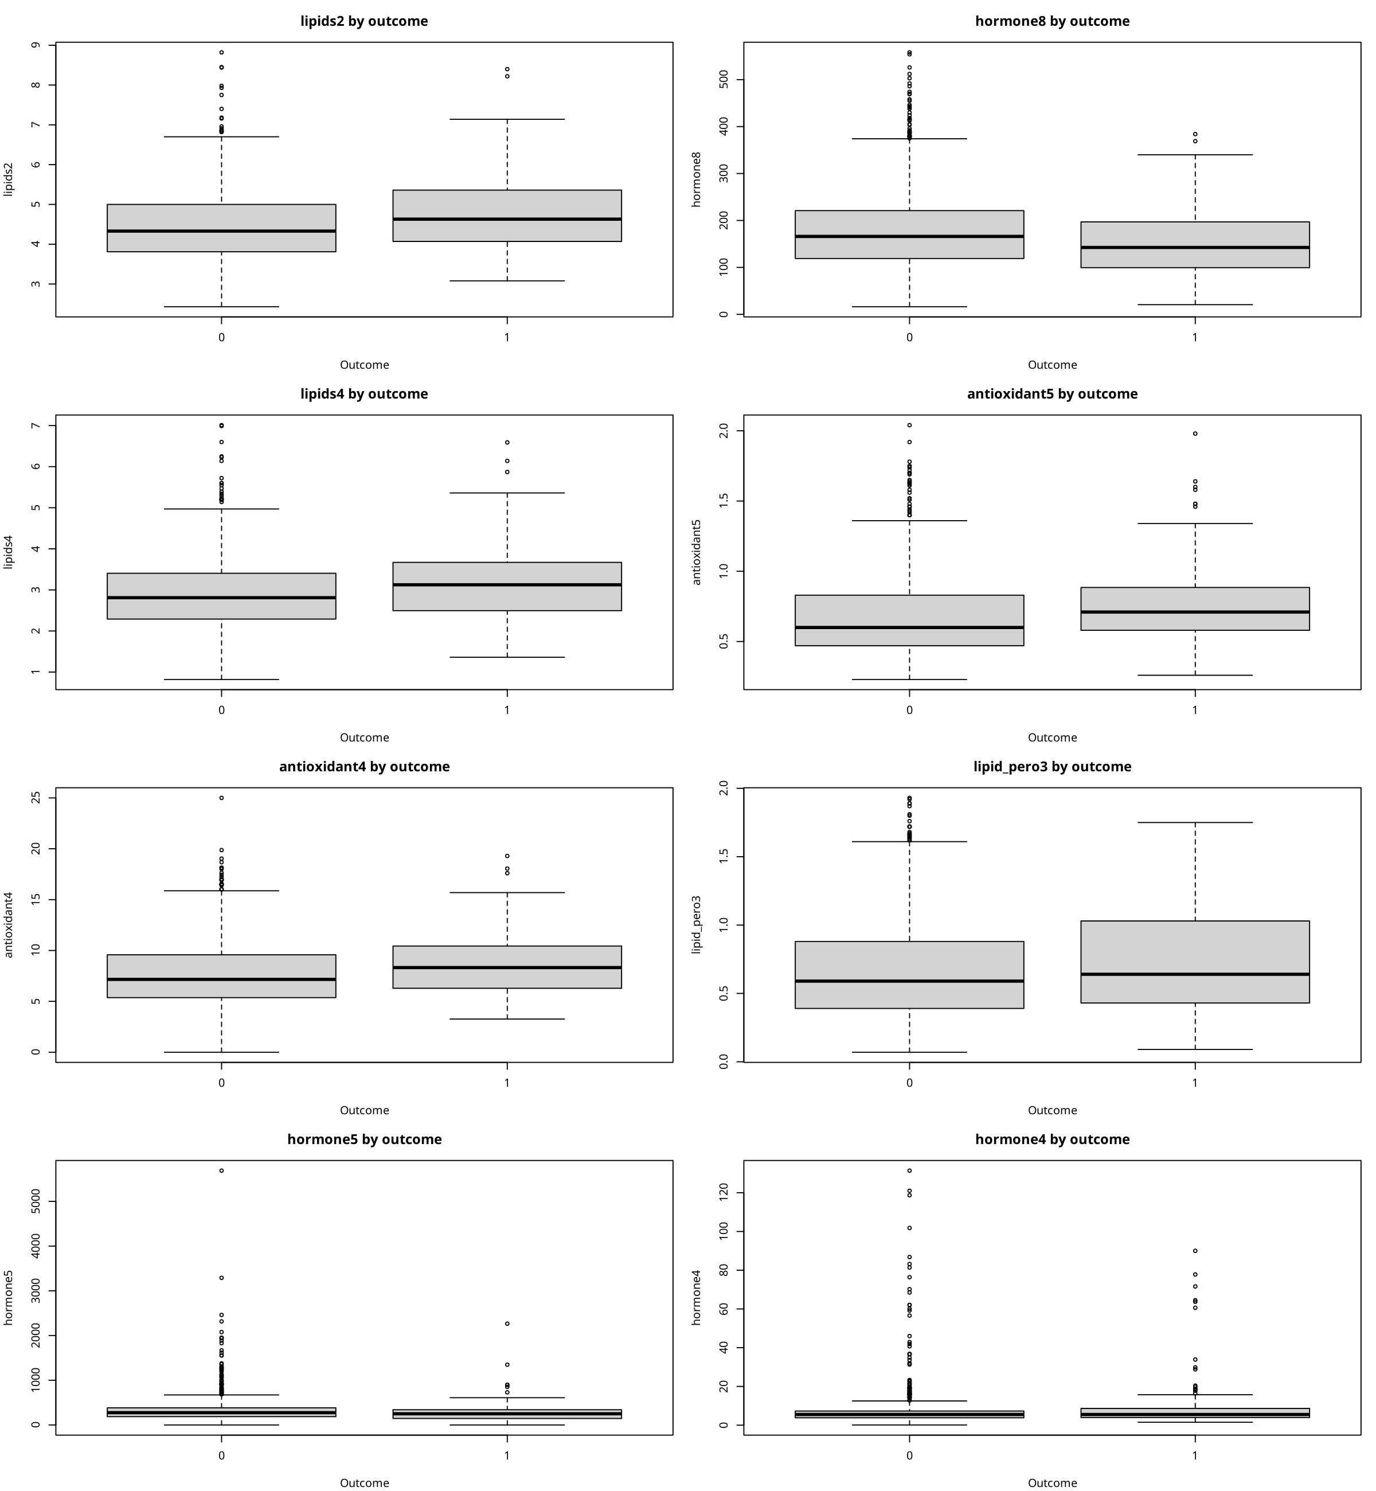
Fifures 4 : final multivariate logistic forest plot
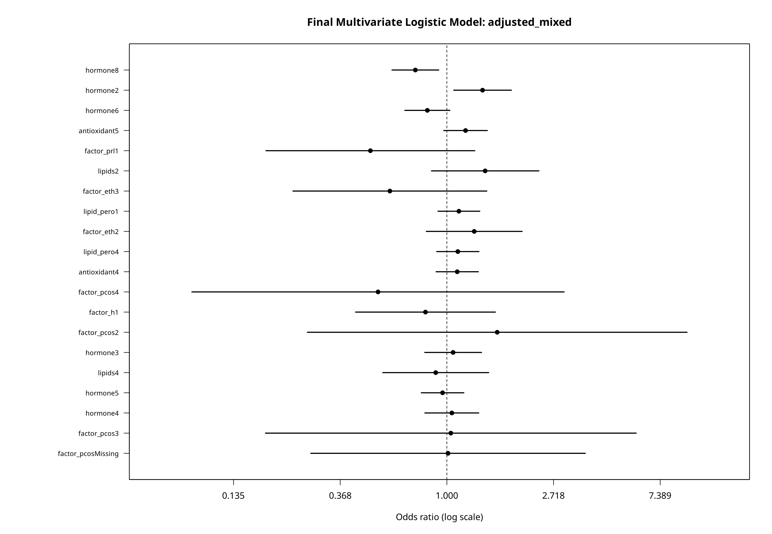
Fifures 5 : continuous variable histograms
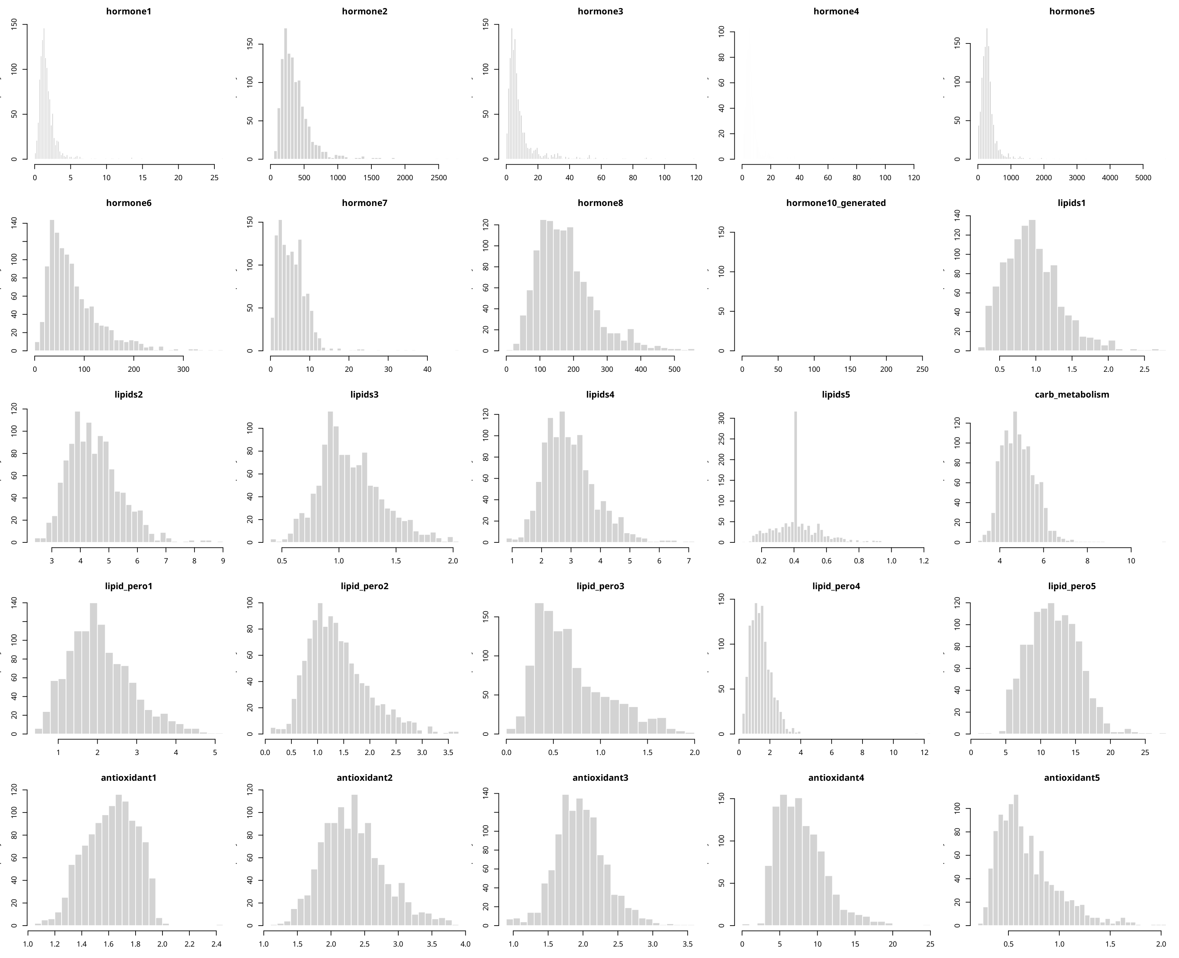

Fifures 6 : pca biplot by outcome
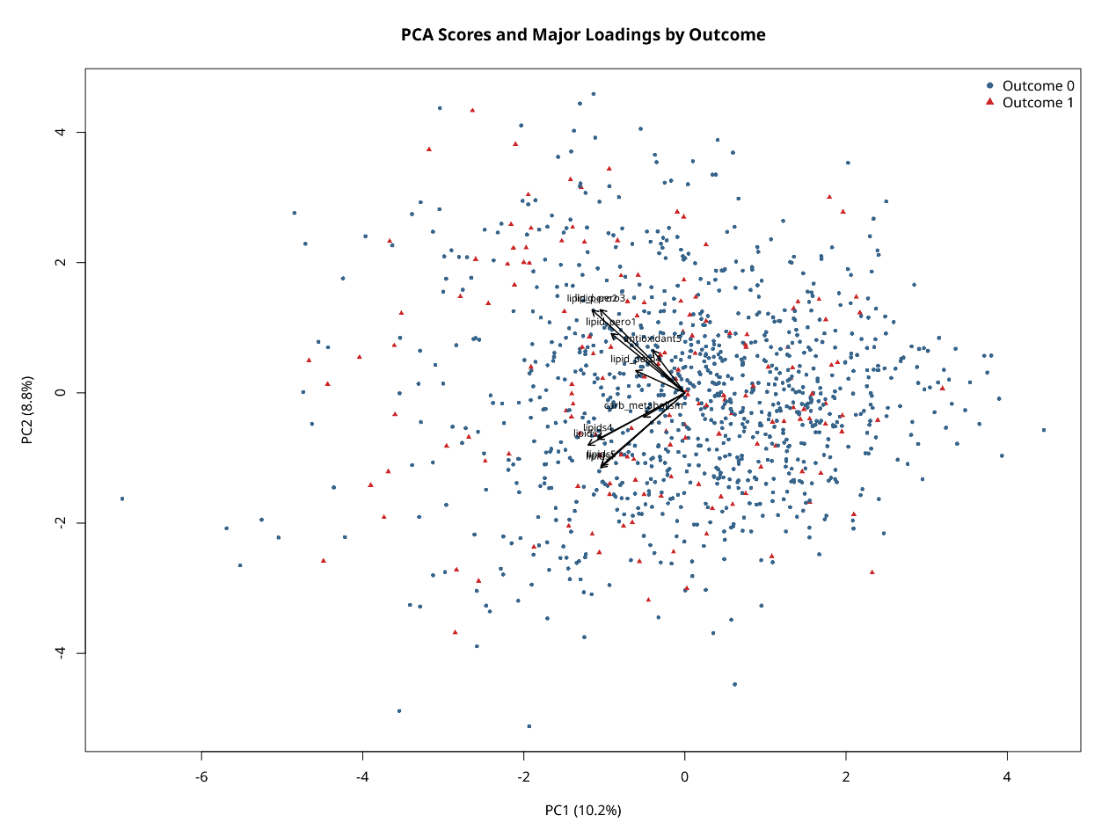
Fifures 7 : kmeans clusters in pca space
